|  |
| --- |
| **Bug ID:** DF_0001 |
| **Severity (Low/Medium/High):** Med |
| **Module Name:** Search functionality |
| **Bug Title:** The default list of cities is not ordered alphabetically |
| **Reported by:** Santiago Passalacqua |
| **Creation date:** 02/05/2020 |
| **Occurrence percentage:** 100% |

|  |
| --- |
| **Pre-conditions:** N/A |
| **Dependencies:** N/A |

|  |
| --- |
| **Step to reproduce** |
| 1. Given the application is up and running 2. When the user sees at the default list of cities 3. Then the list of cities is not ordered alphabetically |
| **Expected Result:** The cities are listed in ascending alphabetical order |

**Evidence:**

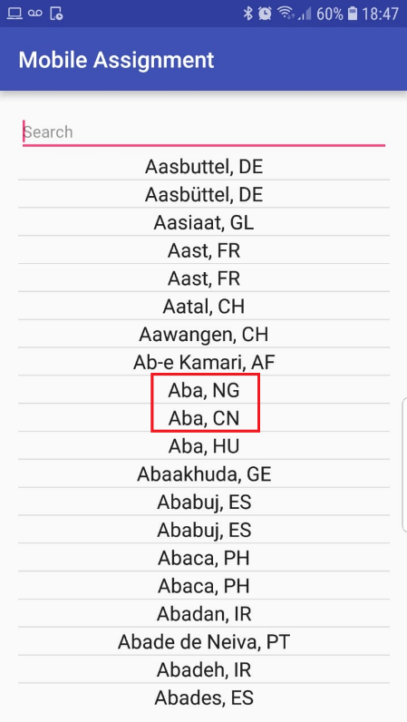“Aba, CN” should be before than “Aba, NG” in the list